**MODERN DATABASE SYSTEM LAB 9**

**RETAIL SALES ANALYTICS PART-IV**

**NAME: PAVITHIRAN.V ROLL.NO: 235229122**

SELECT st.TYPE, AVG(f.TEMPERATURE) AS AvgTemperatureOnHolidays

FROM stores_data st

INNER JOIN (

SELECT STORE_ID, TEMPERATURE, ISHOLIDAY

FROM features_data

WHERE ISHOLIDAY = 'TRUE'

) f ON st.STORE_ID = f.STORE_ID

GROUP BY st.TYPE;

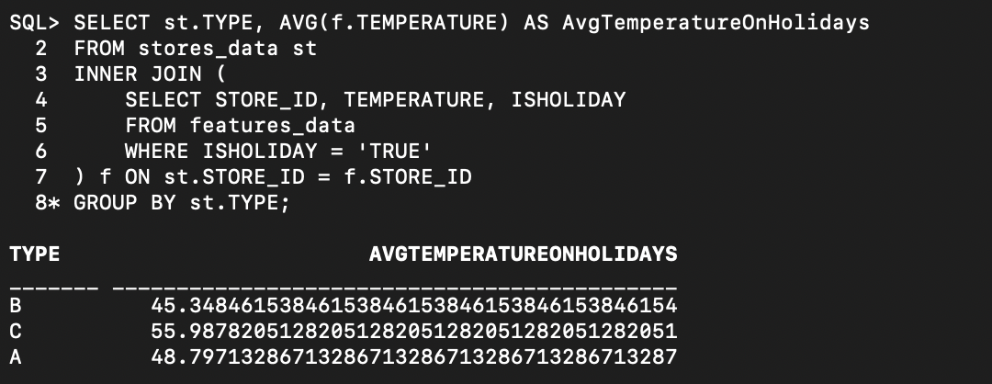

SELECT s.STORE_ID, s.TotalWeeklySales

FROM (

SELECT STORE_ID, SUM(WEEKLY_SALES) AS TotalWeeklySales

FROM sales_data

GROUP BY STORE_ID

HAVING SUM(WEEKLY_SALES) = (

SELECT MAX(SUM(WEEKLY_SALES))

FROM sales_data

GROUP BY STORE_ID

)

) s;

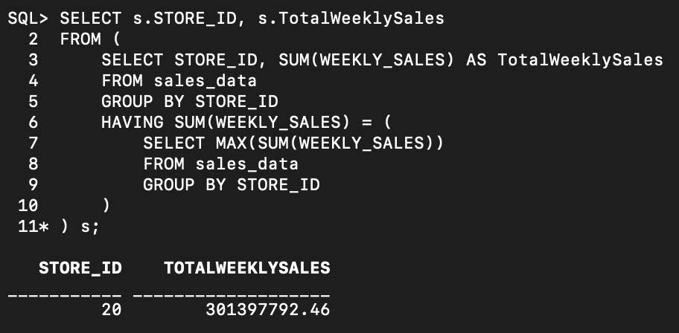

SELECT st.TYPE, AVG(s.TotalWeeklySales) AS AvgWeeklySales

FROM stores_data st

LEFT JOIN (

SELECT STORE_ID, SUM(WEEKLY_SALES) AS TotalWeeklySales

FROM sales_data

GROUP BY STORE_ID

) s ON st.STORE_ID = s.STORE_ID

GROUP BY st.TYPE;

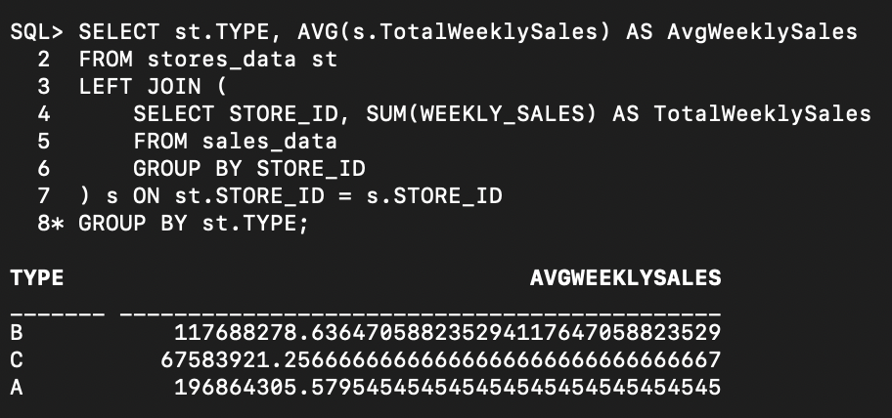

SELECT s.STORE_ID, s.TYPE, s.MAX_WEEKLY_SALES

FROM (

SELECT st.STORE_ID, st.TYPE, MAX(sd.WEEKLY_SALES) AS MAX_WEEKLY_SALES

FROM stores_data st

INNER JOIN sales_data sd ON st.STORE_ID = sd.STORE_ID

GROUP BY st.STORE_ID, st.TYPE

) s

WHERE s.MAX_WEEKLY_SALES = (

SELECT MAX(WEEKLY_SALES)

FROM sales_data

);

